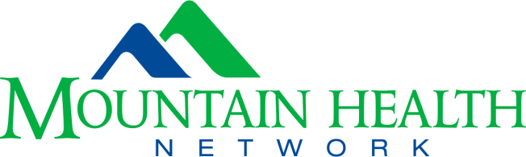

MOUNTAIN HEALTH NETWORK, INC. (MHN)
TUITION ASSISTANCE APPLICATION FORM

PLEASE refer to attached MHN Tuition Assistance Policy

NAME and STUDENT ID NUMBER: | DATE:
MAILING ADDRESS: | PHONE:  E-MAIL:
SCHOOL NAME: | SCHOOL ADDRESS:
PROGRAM: | PROGRAM LENGTH (specify 2 or 4 year):
PROGRAM DIRECTOR NAME: | PROGRAM DIRECTOR PHONE & EMAIL:
SEMESTER REQUESTING TUITION ASSISTANCE: | PROJECTED GRADUATION DATE:

All items below must be included for the application to be considered complete (some items not applicable for St. Mary’s students, please see note below requirements):

____ Resume

____ College Transcript

____ Letter from applicant stating why the applicant wishes to be considered for the tuition assistance award

____ Proof of enrollment (such as printed schedule/dates of classes)

____ Proof of cost (includes tuition and fees)

***Proof of cost and enrollment documents must identify the school term, name of institution and employee’s name. These two items are not required for students in St. Mary’s School of Medical Imaging, Respiratory, or Nursing.

Submit all documentation and application to:
E-mail address: alrena.labus@st-marys.org

By signing below, you attest that you have read and understand the MHN tuition assistance program policy and therefore understand that if you are chosen as a recipient of funds under this Tuition Assistance Program that you will be required to commit to employment within Mountain Health Network as set forth more fully in the Tuition Assistance Program policy and in your tuition award agreement and promissory note.

Applicant Signature Date

